Fall 2021 Criminal Justice Research Experience: Participant Guidelines

This information applies to the following courses:
Course | Sec | Course Title | Meeting Pattern | Instructor
CJ 1310 | 001 | INTRO TO CJ | TR 11am-12:20pm | Robbins, Meagan
CJ 1310 | 002 | INTRO TO CJ | TR 5pm-6:20pm | Tillotson, Stephen
CJ 1310 | 003 | INTRO TO CJ | TR 9:30am-10:50am | Polk, Taylor
CJ 3346 | 001 | RESRCH IN CRIM JST | online | Withrow, Brian
CJ 3346 | 002 | RESRCH IN CRIM JST | MW 2pm-3:20pm | Tillotson, Stephen
CJ 3346 | 003 | RESRCH IN CRIM JST | MW 5pm-6:20pm | Tillotson, Stephen
CJ 3346 | 004 | RESRCH IN CRIM JST | online | Withrow, Brian
CJ 3346 | 005 | RESRCH IN CRIM JST | TR 2pm-3:20pm | Jones, Angela
CJ 3347 | 001 | STATS FOR CRIM JUS | TR 12:30pm-1:50pm | Brimbal, Laure
CJ 3347 | 002 | STATS FOR CRIM JUS | MW 11am-12:20pm | Logan, Matthew
CJ 3347 | 004 | STATS FOR CRIM JUS | TR 3:30pm-4:50pm | Spivey, Emily
CJ 3347 | 005 | STATS FOR CRIM JUS | TR 11am-12:20pm | Chai, April
CJ 3347 | 006 | STATS FOR CRIM JUS | online | Withrow, Brian

As you progress in the Criminal Justice major, you will learn about research in many areas of criminal justice. To enhance your understanding of the nature of social science research, it is important that you get some first-hand experience with research. For that reason, students are required to have direct experience with social science research.

All research with human participants must be carried out in an ethical manner. For example, you cannot be required to participate in studies against your wishes. Therefore, you have two options to fulfill research experience requirement: one option involves participation in studies whereas the other does not. Both options have been designed to take the same amount of effort. You are free to choose either option or both for a total credit balance of 4 credits. The research requirement will be worth 5% of your final grade!

If you fail to complete the research experience requirement (either Option 1 or 2 below, or a combination), then your final course grade will be reduced by one-half of a letter grade (i.e., 5%). The due date to complete your research requirement is Friday, December 3rd by 5pm. No late submissions will be accepted.
Option 1. Volunteer as a Research Participant.

If you are 18 years of age or older, you are eligible to participate in studies (the age restriction is due to federal policy). Your participation in studies will give you a chance to have direct contact with research. Participation in studies at Texas State University that require 29 minutes or less are worth 1 credit; studies that take between 30-59 minutes are worth 2 credits; studies that take between 60-89 minutes are worth 3 credits; studies that take between 90-119 minutes are worth 4 credits. The number of credits will be noted in the study description that you see when you sign up. Only studies approved by the criminal justice department qualify for credit (they will be listed at https://txstatecj.sona-systems.com). In addition, paid studies cannot be used to satisfy the Research Requirement.

To sign up for a study, follow the steps below:
- Go to the website https://txstatecj.sona-systems.com
- Log in with your Texas State credentials (note sona now uses NetID 2-step authentication).
- After you log in, you can sign up for studies, view your accumulated credits, and edit your profile as shown in the screen shot below. You will need to choose the course(s) for which you want your credits to apply.

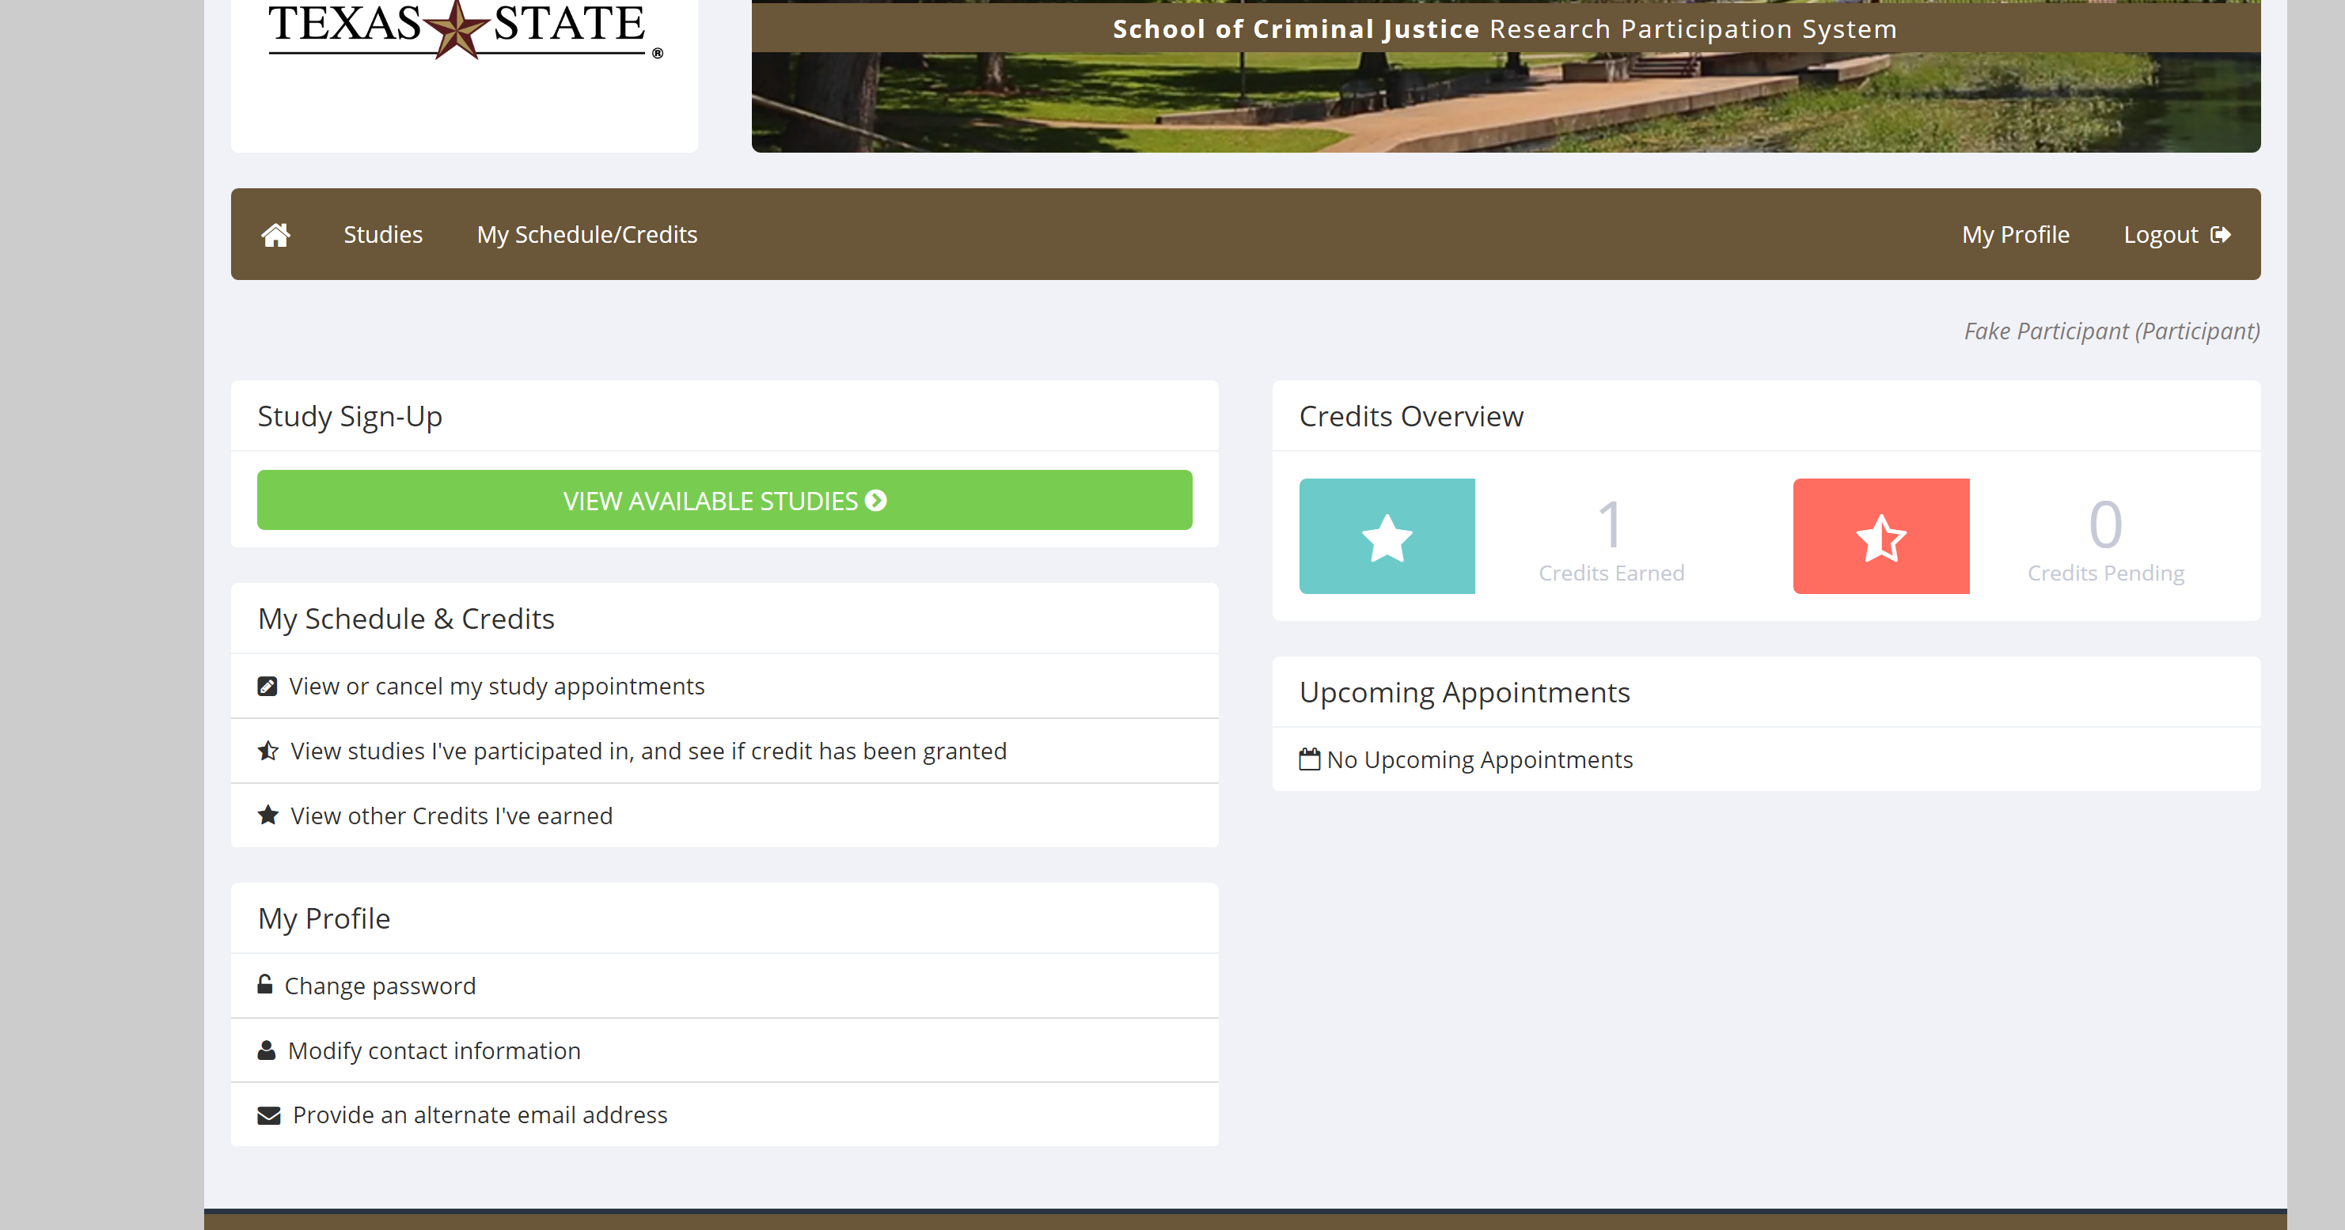

- Look up studies that fit your schedule.
- Online studies can be completed at any time in advance of the researcher’s deadline. Do not sign up for online studies until you are ready to take the study.
- For in person studies, do not sign up to participate unless you intend to show up.
- You may not be able to sign up for future studies if you fail to show up for an appointment that you have made with a researcher, or any time you arrive more than 5 minutes late.
- You may avoid this penalty by canceling your appointment at least 24 hours in advance. You may cancel the appointment by visiting https://txstatecj.sona-systems.com
- Please do not argue with researchers if you arrive late. Once a study has started it is often impossible for a late student to be accommodated.
- Sign up for and complete the studies to get research credit points for your class grade.
- The system will assign you 1 point for each half hour you spend participating in research. Four points of participation, or two hours’ worth of research, will complete the requirement for 5% of your grade.
- Keep your own record of the studies you participate in.
- The last day to participate in studies is Friday, December 3rd, 2021 by 5pm.
- You may need to periodically check in to sona to see what studies are available. Study availability will change throughout the semester at each researcher’s discretion. Do not wait until the last minute to complete studies as this will limit what options you have available.
Option 2. Research Article Summaries

As an alternative to participating in a research study, you may also demonstrate direct contact with research by submitting a written summary of a research article published in Volume 59 (any issue) of the journal Criminology or Volume 17 (any issue) of Journal of Experimental Criminology. Each 500-word written summary is worth 2 credits. To earn credits in this way, follow the steps below:

- Obtain the article(s) in Volume 59 of Criminology or Volume 17 of Journal of Experimental Criminology. Download the article(s) from the online library database. Follow these instructions below to learn how to locate research articles via the library website:

Using the Periodical List to Find Articles
A. Copy and paste the JOURNAL TITLE into the Periodicals search on the homepage.

B. You should see something like this:

C. Follow the link that corresponds to present day availability (newly published articles). There may be multiple links to choose from. Click on any of the issues within the appropriate volume and choose an article of your liking to summarize (Volume 59 of Criminology or Volume 17 of Journal of Experimental Criminology).

- Read and summarize the article. Each summary should include a description of the research problem, the theory being tested, the methodology used, the findings, and how the study contributed to social science research.
- Papers should be written in complete sentences USING YOUR OWN WORDS, avoiding direct quotes. If plagiarism is detected in your article summary, you will lose the opportunity to earn that credit through article submission. You might then (a) complete a study to replace it or (b) lose the credit.
- Each summary should be two typed, double spaced pages totaling approximately 500 words with one-inch margins and 12-point font.
- Submit article summaries to the following email: sonasystem4cj@txstate.edu by the research experience deadline (Friday, December 3rd, 2021 by 5pm). You must include your name, class and section number, and your professor’s name in the subject line. You must also include the APA reference for the article you are summarizing in the body of the email. Save the file as either a Word document or PDF as Lastname_Firstname#. If your name is Angela Jones, save as Jones_Angela1 or Jones_Angela2 (if you are submitting two summaries).

Summary

- Research Experience is worth 5% of your course grade. Research credits can be tracked by logging into https://txstatecj.sona-systems.com as described above.
- Additional details, including frequently asked questions, can be found at: http://www.cj.txstate.edu/resources/research-experience.html.
- Please direct any questions regarding the research experience requirement to the Research Experience Coordinator at sonasystem4cj@txstate.edu.
- Make sure that your research summaries meet the word count
  - Please include your name, what class and section you are in, and the APA reference of what journal article you used when you submit the research summary
  - Save the file as either a Word document or PDF as Lastname_Firstname#.
  - Titles, your name, and references do not count towards the word count
  - Any summaries that are submitted without meeting the word count will not be graded
  - Any submissions past the due date will not be graded
- Please do not email your professor or the SONA coordinator asking if there is anything you can do to make up the grade once the deadline has passed
- If you sign up for a face-to-face research study, please be on time and make your appointment. If you cannot make your appointment, please let the researcher know a MINIMUM of 24 hours in advance. If you do not show up and the researcher was not notified, this may affect your ability to participate in research studies on the SONA website. In other words, ONE TIME of not showing up to a research study or doing an online study before the deadline has passed can automatically limit you from doing any further research studies.

