Critical Reaction Paper Outline
Review the purpose of the assignment and the assignment rubric:
The purpose of the Critical Reaction assignment is to help you develop your critical thinking through writing. The paper is a short reflection paper that makes a specific argument in response to one text of your choice. The critical reaction paper is not a summary or personal reflection about the text you choose, rather the focus is on making intertextual connections between your selected text and three additional sources.
Your critical reaction paper should be 4-5-pages long and use MLA formatting (i.e. double-spaced, 12-point font, 1” margins, etc.) Pay special care to cite quotes within the paper according to MLA as well.
Think about the following as you construct your reaction:
- Start with a compelling introduction that includes a strong thesis statement: Your introduction should capture the reader’s attention, and the thesis statement should guide your whole paper.
- Stay on track: Staying on track has to do with organization of your paper. Consider your reader. Know where you are headed and make sure your reader does too. (A good outline will guide your paper, so make one before you begin writing.) Each paragraph should connect back to your guiding thesis statement.
- Maintain clarity: Don’t assume the reader understands the argument you are making. (It’s tempting to write with your professor in mind--who has full knowledge of the readings—as your audience. Resist this—write as though you are explaining yourself to someone who has no prior knowledge of the texts.)
- Offer analysis and support your analysis with evidence from the texts: Make logical connections from your analysis of a point with supporting evidence from the texts, then explain it for the reader. Your analysis should answer the “So what?” question we’ve talked about in class.
- Use quotes sparingly: I want to hear your voice, your analysis, and your explanation. The quotes are included as support, not as the bulk of your paper.
- Conclude your paper with some novel insight into the reading. This doesn’t mean invent something all-together new, it just means that your conclusion should highlight why you think what you wrote is interesting and offers a new (your) perspective to the two works discussed.
- Check (and double check) your MLA formatting and works cited.

A superior assignment will be creative in its presentation and carefully provide specific detailed examples which also attend to grammar and style. A superior assignment will also utilize MLA formatting guidelines.

Please view the full rubric in Canvas

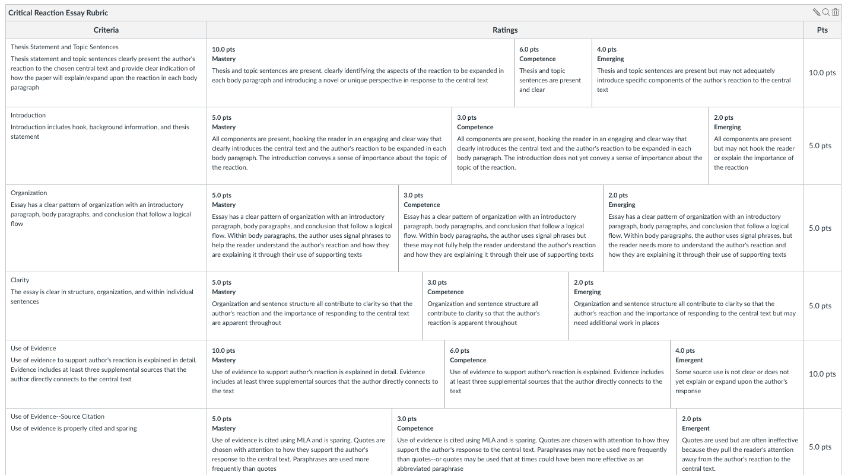

We will begin outlines and notetaking for the essay today in class.

Critical Reaction Infographic/Graphic Organizer
Central Text
Title
Author (if present)
Text purpose and central themes/ideas

Your response to one of those themes

Supplemental Text 1:
Title
Author (if present)
Text purpose and central themes/ideas

Connections between the Central text and this supplemental text
EXAMPLE:
Supplemental Text 0: National Immigration Law Center FAQs
National Immigration Law Center
Informs individuals interested in applying for DACA about the application process and the consequences of Trump’s election on applying for DACA

Like Define American, this text speaks clearly to the need for DACA and the benefits of obtaining papers.

Unlike Define American, this text focuses on the legal side of applying. It doesn’t address the emotional aspects of fearing deportation or the ways that DACA applicants feel they are already “at home” and “American.”

“When people apply for DACA, they apply at the same time for “employment authorization” (a work permit). If they receive DACA, they also receive a work permit that is valid for the same amount of time as their DACA” (National Immigration Law Center, n.p.)

Supplemental Text 2:
Title
Author (if present)
Text purpose and central themes/ideas

Connections between the Central text and this supplemental text

Evidence (quotes from the text that show the connection or support my reaction)
Supplemental Text 3:
Title
Author (if present)
Text purpose and central themes/ideas

Connections between the Central text and this supplemental text

Evidence (quotes from the text that show the connection or support my reaction)

  - Introduction
        - Hook: How will you grab your reader’s interest?

        - Background Information: What information does your reader need to know about your peer’s paper in order to understand your position?

        - Thesis Statement: What is your reaction to your central text?

  - Body Paragraphs
- Topic Sentence: What one specific aspect of the central text that you will respond to in this paragraph? How does this specific aspect strengthen your explanation of your own position?

        - Supporting Details to Provide Evidence and Explanation
        - Connecting to Your Reaction to the Central Text (how does this text help the reader understand your reaction to the central text?)

- Topic Sentence: What one specific aspect of the central text that you will respond to in this paragraph? How does this specific aspect strengthen your explanation of your own position?

        - Supporting Details to Provide Evidence and Explanation
        - Connecting to Your Reaction to the Central Text (how does this text help the reader understand your reaction to the central text?)

- Topic Sentence: What one specific aspect of the central text that you will respond to in this paragraph? How does this specific aspect strengthen your explanation of your own position?

        - Supporting Details to Provide Evidence and Explanation
        - Connecting to Your Reaction to the Central Text (how does this text help the reader understand your reaction to the central text?)

  - Conclusion
        - Return to your purpose: What is your purpose for writing this essay?

        - Answer the question “So What?”

